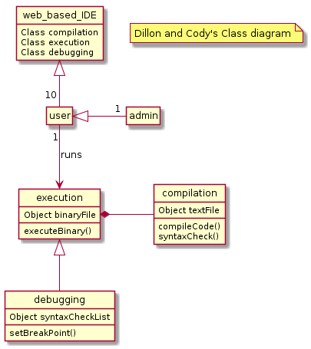

@startuml

hide circle

hide empty methods

hide empty fields

note "Dillon and Cody's Class diagram" as N1

class web_based_IDE

class user

class admin

class execution

class debugging

class compilation

web_based_IDE <|-- "10"user

execution *- compilation

execution <|-- debugging

user <|- "1"admin

user "1"--> execution : runs

web_based_IDE : Class compilation

web_based_IDE : Class execution

web_based_IDE : Class debugging

compilation : compileCode()

compilation : Object textFile

compilation : syntaxCheck()

execution : Object binaryFile

execution : executeBinary()

debugging : Object syntaxCheckList

debugging : setBreakPoint()

@enduml